NAME : MAKVANA NEEL

ROLL NO : CE064

ID : 20CEUOS086

BATCH : A4

SDP-LAB08:

Code test:1

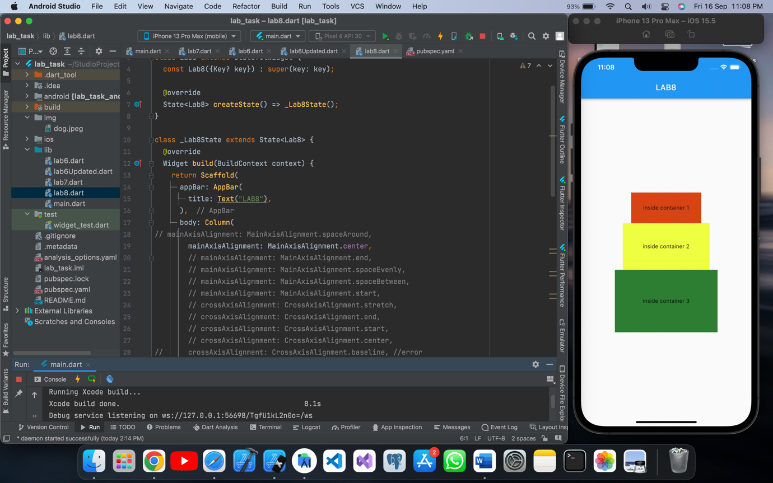

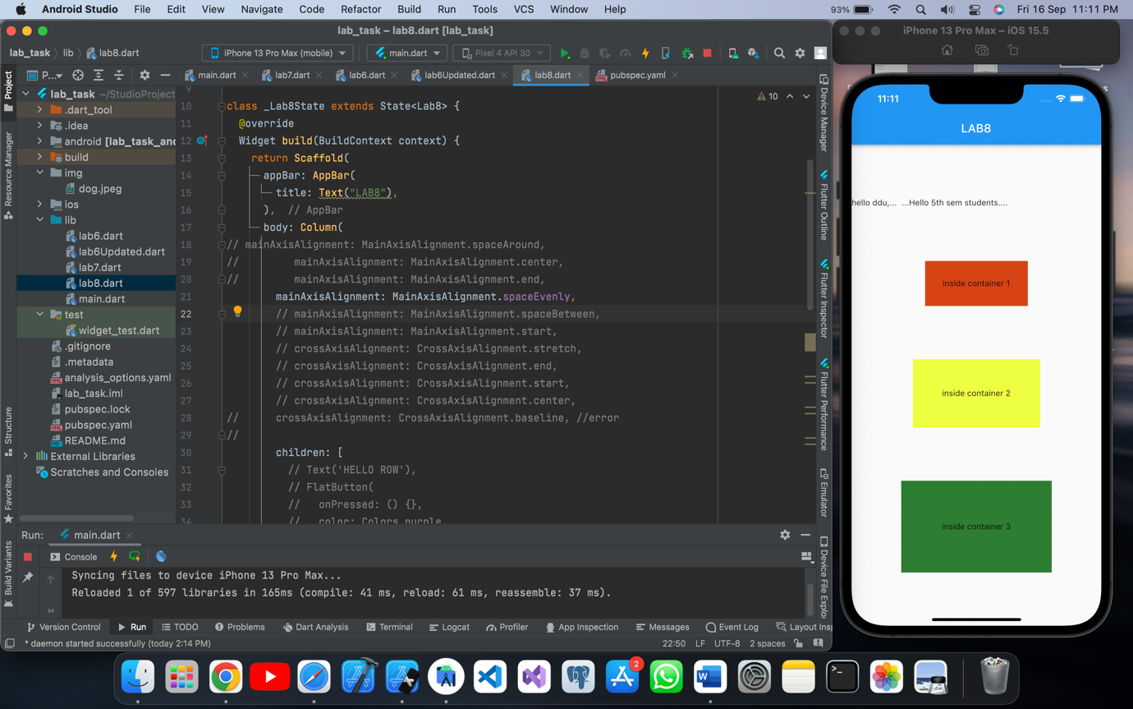

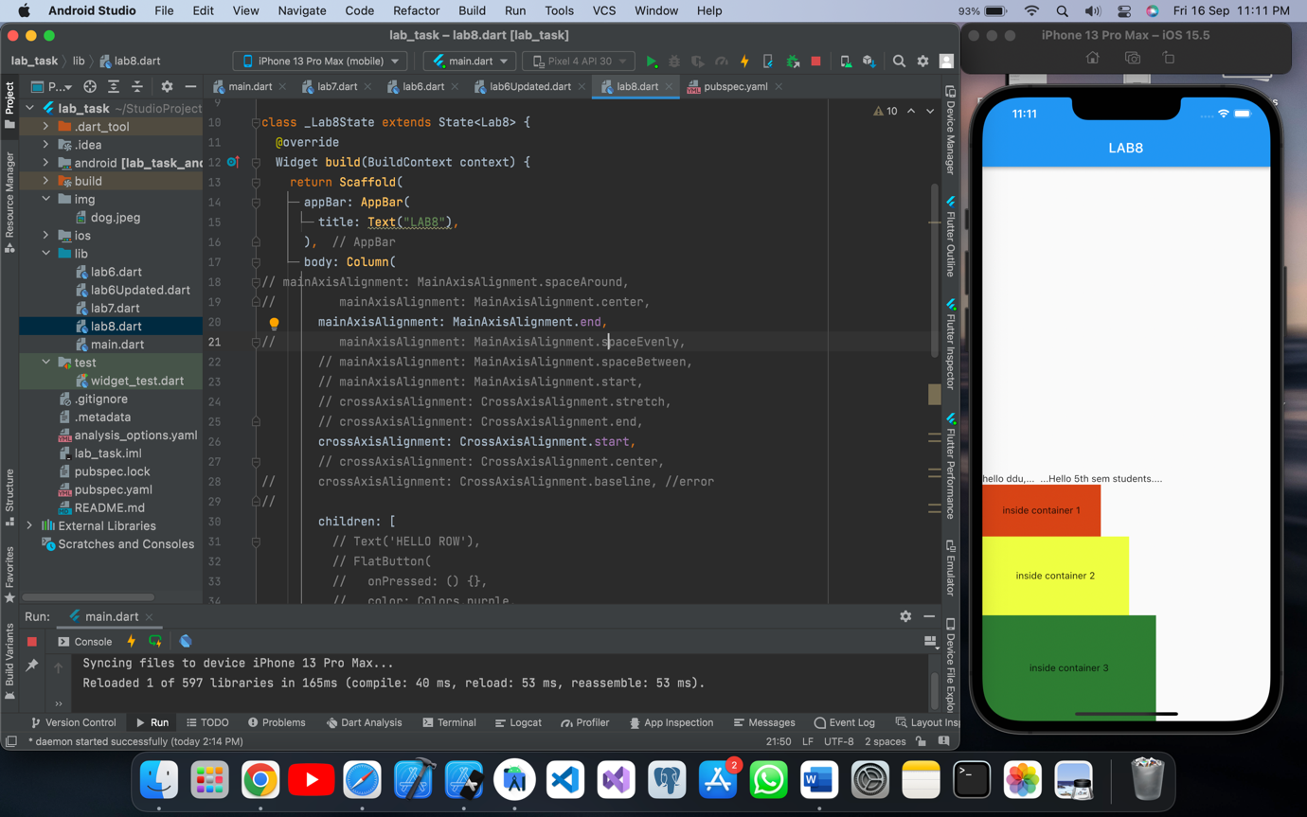

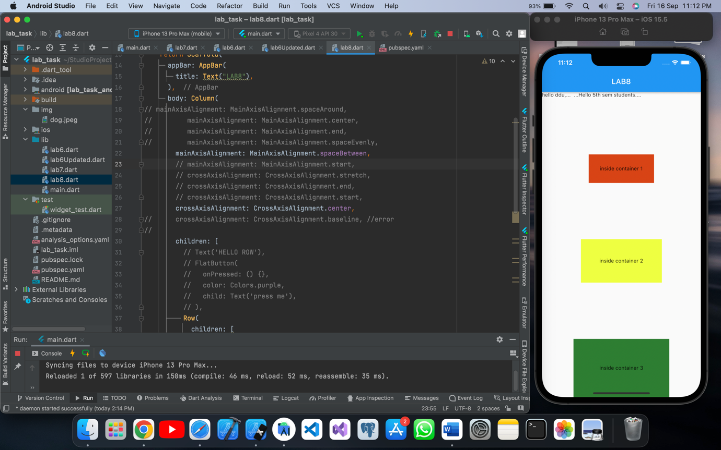

Code test 2:

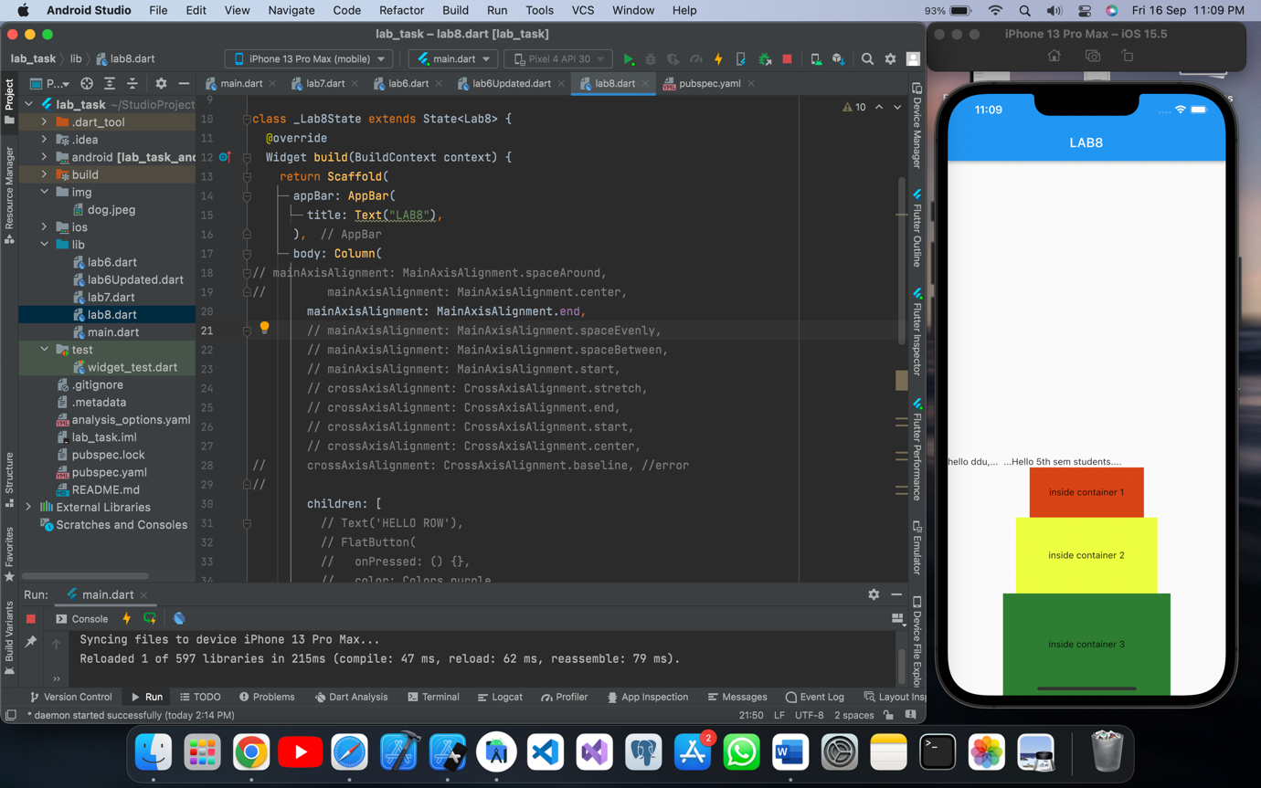

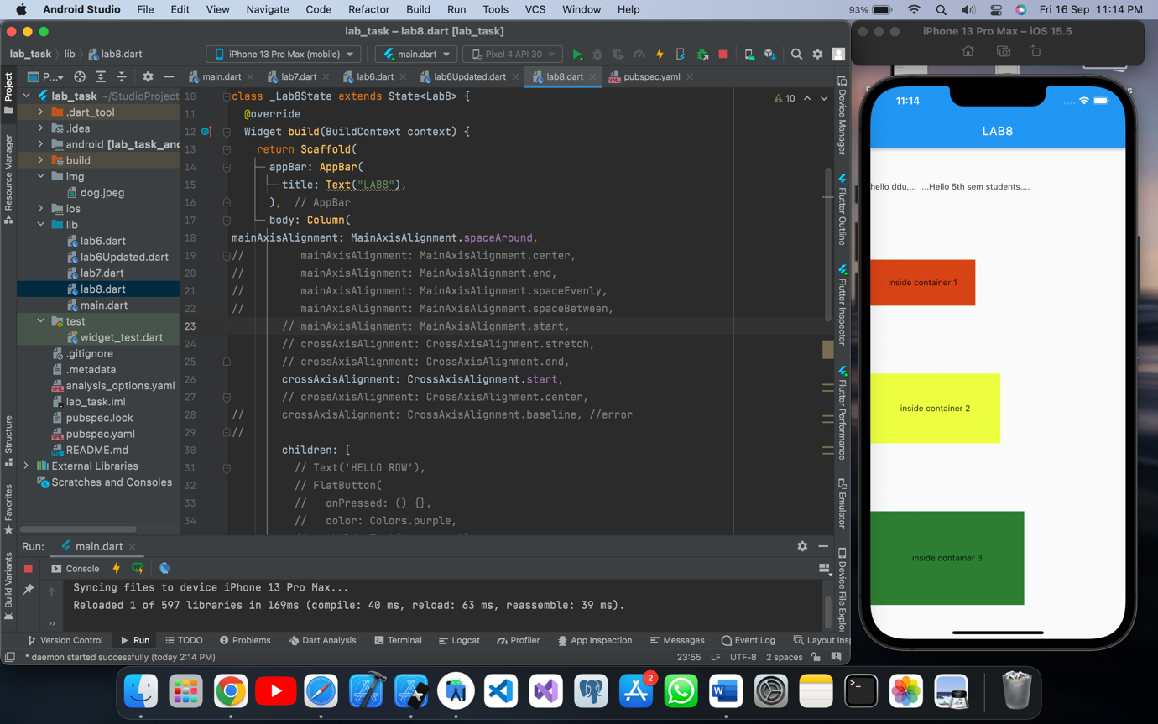

Final code design screen shot:

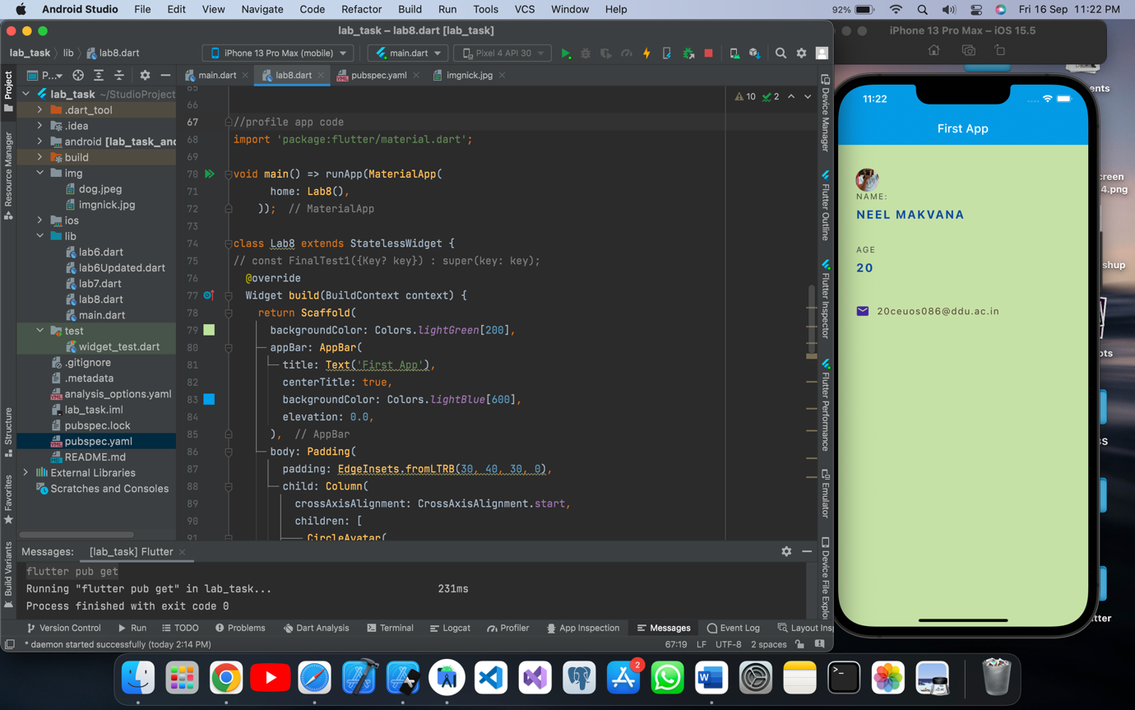

Final code of column and row:

//understand the row and column:  
  
// import 'package:flutter/material.dart';  
//  
// class Lab8 extends StatefulWidget {  
// const Lab8({Key? key}) : super(key: key);  
//  
// @override  
// State<Lab8> createState() => _Lab8State();  
// }  
//  
// class _Lab8State extends State<Lab8> {  
// @override  
// Widget build(BuildContext context) {  
// return Scaffold(  
// appBar: AppBar(  
// title: Text("LAB8"),  
// ),  
// body: Column(  
// mainAxisAlignment: MainAxisAlignment.spaceAround,  
// // mainAxisAlignment: MainAxisAlignment.center,  
// // mainAxisAlignment: MainAxisAlignment.end,  
// // mainAxisAlignment: MainAxisAlignment.spaceEvenly,  
// // mainAxisAlignment: MainAxisAlignment.spaceBetween,  
// // mainAxisAlignment: MainAxisAlignment.start,  
// // crossAxisAlignment: CrossAxisAlignment.stretch,  
// // crossAxisAlignment: CrossAxisAlignment.end,  
// crossAxisAlignment: CrossAxisAlignment.start,  
// // crossAxisAlignment: CrossAxisAlignment.center,  
// // crossAxisAlignment: CrossAxisAlignment.baseline, //error  
// //  
// children: [  
// // Text('HELLO ROW'),  
// // FlatButton(  
// // onPressed: () {},  
// // color: Colors.purple,  
// // child: Text('press me'),  
// // ),  
// Row(  
// children: [  
// Text('hello ddu,... '),  
// Text(' ...Hello 5th sem students....')  
// ],  
// ),  
// Container(  
// color: Colors.deepOrange[800],  
// padding: EdgeInsets.all(30.0),  
// child: Text('inside container 1'),  
// ),  
// Container(  
// color: Colors.limeAccent,  
// padding: EdgeInsets.all(50.0),  
// child: Text('inside container 2'),  
// ),  
// Container(  
// color: Colors.green[800],  
// padding: EdgeInsets.all(70.0),  
// child: Text('inside container 3'),  
// ),  
// ],  
// ),  
// );  
// }  
// }

Final code of profile app code :

//profile app code  
import 'package:flutter/material.dart';  
  
void main() => runApp(MaterialApp(  
 home: Lab8(),  
 ));  
  
class Lab8 extends StatelessWidget {  
// const FinalTest1({Key? key}) : super(key: key);  
 @override  
 Widget build(BuildContext context) {  
 return Scaffold(  
 backgroundColor: Colors.*lightGreen*[200],  
 appBar: AppBar(  
 title: Text('First App'),  
 centerTitle: true,  
 backgroundColor: Colors.*lightBlue*[600],  
 elevation: 0.0,  
 ),  
 body: Padding(  
 padding: EdgeInsets.fromLTRB(30, 40, 30, 0),  
 child: Column(  
 crossAxisAlignment: CrossAxisAlignment.start,  
 children: [  
 CircleAvatar(  
 backgroundImage: AssetImage('img/imgnick.jpg'),  
 ),  
 Text(  
 'NAME: ',  
 style: TextStyle(  
 color: Colors.*grey*[800],  
 letterSpacing: 2.0,  
 ),  
 ),  
 SizedBox(height: 10),  
 Text(  
 'NEEL MAKVANA',  
 style: TextStyle(  
 color: Colors.*blue*[900],  
 letterSpacing: 2.0,  
 fontWeight: FontWeight.*bold*,  
 fontSize: 20.0,  
 ),  
 ),  
 SizedBox(height: 40),  
 Text(  
 'AGE',  
 style: TextStyle(  
 color: Colors.*grey*[800],  
 letterSpacing: 2.0,  
 ),  
 ),  
 SizedBox(height: 10),  
 Text(  
 '20',  
 style: TextStyle(  
 color: Colors.*blue*[900],  
 letterSpacing: 2.0,  
 fontWeight: FontWeight.*bold*,  
 fontSize: 20.0,  
 ),  
 ),  
 SizedBox(height: 50),  
 Row(  
 children: [  
 Icon(  
 Icons.*email_rounded*,  
 color: Colors.*deepPurple*[800],  
 ),  
 SizedBox(width: 12.0),  
 Text(  
 '20ceuos086@ddu.ac.in',  
 style: TextStyle(  
 color: Colors.*brown*[800],  
 fontSize: 16.0,  
 letterSpacing: 1.5,  
 ),  
 )  
 ],  
 )  
 ],  
 ),  
 ),  
 );  
 }  
}